**Lab -02**

**Examples of Arrays**

**1. Array Initialization and Accessing Elements**

#include <iostream>

using namespace std;

int main() {

int arr[5] = {10, 20, 30, 40, 50};

cout << "First element: " << arr[0] << endl;

cout << "Third element: " << arr[2] << endl;

return 0;

}

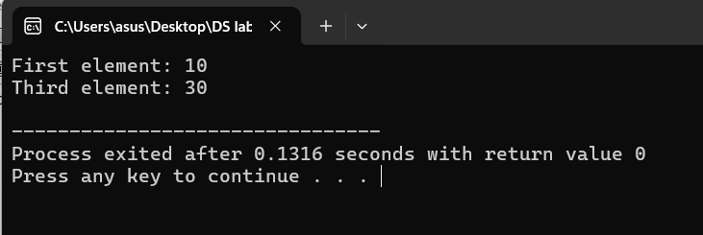

**2. Sum of Array Elements**

#include <iostream>

using namespace std;

int main() {

int arr[5] = {10, 20, 30, 40, 50};

int sum = 0;

for(int i = 0; i < 5; i++) {

sum += arr[i];

}

cout << "Sum of array elements: " << sum << endl;

return 0;

}

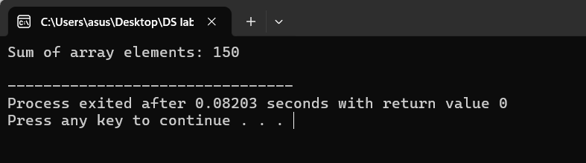

**3. Find Maximum Value in Array**

#include <iostream>

using namespace std;

int main() {

int arr[5] = {10, 25, 15, 5, 20};

int max = arr[0];

for(int i = 1; i < 5; i++) {

if(arr[i] > max) {

max = arr[i];

}

}

cout << "Maximum value: " << max << endl;

return 0;

}

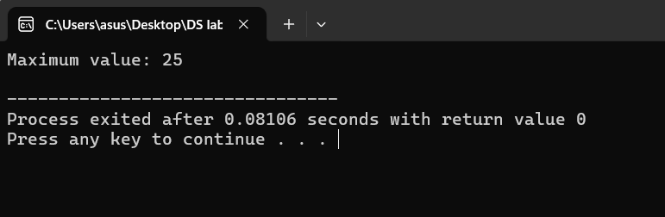

**4. Find Minimum Value in Array**

#include <iostream>

using namespace std;

int main() {

int arr[5] = {10, 25, 15, 5, 20};

int min = arr[0];

for(int i = 1; i < 5; i++) {

if(arr[i] < min) {

min = arr[i];

}

}

cout << "Minimum value: " << min << endl;

return 0;

}

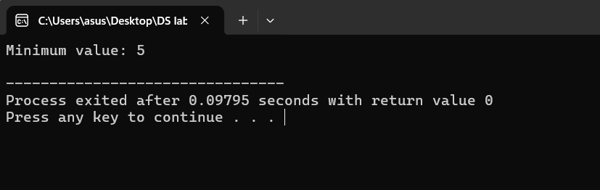

**5. Find the Average of Array Elements**

#include <iostream>

using namespace std;

int main() {

int arr[5] = {10, 20, 30, 40, 50};

int sum = 0;

for(int i = 0; i < 5; i++) {

sum += arr[i];

}

float average = sum / 5.0;

cout << "Average value: " << average << endl;

return 0;

}

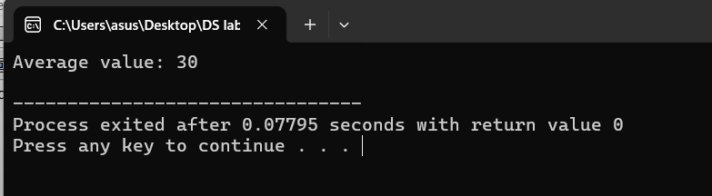

**6. Reverse Array Elements**

#include <iostream>

using namespace std;

int main() {

int arr[5] = {10, 20, 30, 40, 50};

cout << "Reversed array: ";

for(int i = 4; i >= 0; i--) {

cout << arr[i] << " ";

}

return 0;

}

